ASSIGNMENT:
- identify a problem that can be solved by a protagonist with power to act, 2) identify and thoroughly analyze issues that will assist in solving the problem, showing the application of case data and facts, 3) offer a direct and logical solution to the problem that is justified by the results of the analysis of the issues, 4) offer a complete and realistic set of steps to implement the solution. All parts of the assignment are expected to be logically connected. All presentation slides or media need to be easy to read and follow

H. J. Heinz Company:
The Administration of Policy (A)
April is the cruelest month.
T. S. Eliot
In April 1979 James Cunningham, H. J. Heinz Company’s president and chief operating
officer, learned that since 1972 certain Heinz divisions had allegedly engaged in improper income
transferal practices. Payments had been made to certain vendors in a particular fiscal year, then
repaid or exchanged for services in the succeeding fiscal year.1
These allegations came out during the investigation of an unrelated antitrust matter.
Apparent improprieties were discovered in the records of the Heinz USA division’s relationship with
one of its advertising agencies. Joseph Stangerson—senior vice president, secretary, and general
counsel for Heinz—asked the advertising agency about the alleged practices. Not only had the agency
personnel confirmed the allegation about Heinz USA, it indicated that similar practices had been
used by Star-Kist Foods, another Heinz division. The divisions allegedly solicited improper invoices
from the advertising agency in fiscal year (FY) 1974 so that they could transfer income to FY 1975.
While the invoices were paid in FY 1974, the services described on the invoices were not rendered
until some time during FY 1975. Rather than capitalizing the amount as a prepaid expense, the
amount was charged as an expense in FY 1974. The result was an understatement of FY 1974 income
and an equivalent overstatement of FY 1975 income. Stangerson reported the problem to John Bailey, vice chairman and chief executive officer; to Robert Kelly, senior vice president-finance and treasurer; and to Cunningham. Bailey, CEO since
1966, had presided over 13 uninterrupted years of earnings growth. He was scheduled to retire as
vice chairman and CEO on July 1 and would remain as a member of the board of directors. James
Cunningham, who had been president and chief operating officer since 1972, was to become chief
executive officer on July 1, 1979.
Subsequent reports indicate that neither the scope of the practice nor the amounts involved
were known. There was no apparent reason to believe that the amounts involved would have had a
material effect on Heinz’s reported earnings during the time period, including earnings for FY 1979
ending May 2. (Heinz reported financial results on the basis of a 52–53 week fiscal year ending on the
Wednesday closest to April 30.) Stangerson was not prepared to say whether the alleged practices
were legal or illegal. “This thing could be something terrible or it could be merely a department head
using conservative accounting practices; we don’t know,”2 one Heinz senior official stated to the
press.
Background
Henry J. Heinz, on founding the company in 1869 in Pittsburgh, Pennsylvania, said: “This is
my goal—to bring home-cooking standards into canned foods, making them so altogether wholesome
and delicious and at the same time so reasonable that people everywhere will enjoy them in
abundance.”3 The company’s involvement in food products never changed, and in 1979 Heinz
operated some 30 companies with products reaching 150 countries. Heinz reported sales of over $2.2
billion and net income of $99.1 million in FY 1978.
After a sluggish period in the early 1960s, a reorganization was undertaken to position Heinz
for growth. Under the guidance of John Bailey and James Cunningham, Heinz prospered through a
major recession, government price controls, and major currency fluctuations. The 1978 annual report
reflected management’s pride in Heinz’s remarkably consistent growth:
Fiscal 1978 went into the books as the fifteenth consecutive year of record
results for Heinz. Earnings rose to another new high. Sales reached more than $2
billion only six years after we had passed the $1 billion mark for the first time in our
century-long history. We are determined to maintain the financial integrity of our
enterprise and support its future growth toward ever-higher levels. [Exhibit 1
presents a financial summary of fiscal years 1972–1978.]
Although Heinz was a multinational firm, domestic operations accounted for 62% of sales
and 67% of earnings in FY 1978. Five major divisions operated in the United States in 1979.
Throughout the 1970s Heinz’s major objective was consistent growth in earnings. While
Heinz management did not consider acquisitions to be crucial to continuing growth, it looked
favorably on purchase opportunities in areas where Heinz had demonstrated capabilities. Bailey and
Cunningham stressed profit increases through the elimination of marginally profitable products.
Increased advertising of successful traditional products and new product development efforts also
contributed to Heinz’s growth. Heinz’s commitment to decentralized authority as an organizational
principle aided the management of internal growth as well as acquisitions.
Organization
In 1979 Heinz was organized on two primary levels. The corporate world headquarters,
located in Pittsburgh, consisted of the principal corporate officers and historically small staffs
(management described the world headquarters as lean). World headquarters had the responsibility
for “the decentralized coordination and control needed to set overall standards and ensure
performance in accordance with them.”4 Some Heinz operating divisions reported directly to the
president; others reported through senior vice presidents who were designated area directors (see
Exhibit 2). World headquarters officers worked with division senior managers in areas such as
planning, product and market development, and capital programs.
Heinz’s divisions were largely autonomous operating companies. Division managers were
directly responsible for the division’s products and services, and they operated their own research
and development, manufacturing, and marketing facilities. Division staff reported directly to division
managers and had neither formal reporting nor dotted-line relationships with corporate staff.
World headquarters officers monitored division performance through conventional business
budgets and financial reports. If reported performance was in line with corporate financial goals, little
inquiry into the details of division operation was made. On the other hand, variations from planned
performance drew a great deal of attention from world headquarters; then, divisions were pressured to
improve results. A review was held near the end of the third fiscal quarter to discuss expected year-end
results. If shortfalls were apparent, other divisions were often encouraged to improve their performance.
The aim was to meet projected consolidated earnings and goals. Predictability was a watchword and
surprises were to be avoided.5 A consistent growth in earnings attended this management philosophy.
Management Incentive Plan
Designed by a prominent management consulting firm, the management incentive plan (MIP)
was regarded as a prime management tool used to achieve corporate goals.6 MIP comprised roughly
225 employees, including corporate officers, senior world headquarters personnel, and senior
personnel of most divisions. Incentive compensation was awarded on the basis of an earned number
of MIP points and in some cases reached 40% of total compensation.
MIP points could be earned through the achievement of personal goals. These goals were
established at the beginning of each fiscal year in consultation with the participant’s immediate
supervisor. Points were awarded by the supervisor at the end of the year, based on goal achievement.
In practice, personal goal point awards fell out on a curve, with few individuals receiving very high
or very low awards.
MIP points were also awarded based on net profit after tax (NPAT) goals. (On occasion, other
goals such as increased inventory turnover or improved cash flow were included in MIP goals.)
Corporate NPAT goals were set at the beginning of the fiscal year by the management development
and compensation committee (MDC) of the board of directors. The chief executive officer, the chief
operating officer, the senior vice president-finance, and the senior vice president-corporate
development then set MIP goals for each division, with the aggregate of division goals usually
exceeding the corporate goal. Two goals were set—a fair goal, which was consistently higher than
the preceding year’s NPAT, and a higher outstanding goal. The full number of MIP points was
earned by achieving the outstanding goal.
Senior corporate managers were responsible for executing the system. While divisional input
was not uncommon, division NPAT goals were set unilaterally and did not necessarily reflect a
division’s budgeted profits. Once set, goals were seldom changed during the year. The officers who
set the goals awarded MIF points at the end of the fiscal year. No points were awarded to personnel
in a division that failed to achieve its fair goal, and points were weighted to favor results at or near
the outstanding goal. One or more bonus points might be awarded if the outstanding goal was
exceeded. Corporate officers also had the authority to make adjustments or award arbitrary points in
special circumstances. The basis for these adjustments was not discussed with division personnel.
MIP points for consolidated corporate performance were awarded by the MDC committee of
the board. Corporate points were credited to all MIP participants except those in a division that did
not achieve its fair goal. The MDC committee could also award company bonus points.
Heinz also had a long-term incentive plan based on a revolving three-year cycle. Participation
was limited to senior corporate management and division presidents or managing directors for a total
of 19 persons.
Corporate Ethical Policy
Heinz had an explicit corporate ethical policy that was adopted in May 1976.7 Among other
things, it stated that no division should:
1. have any form of unrecorded assets or false entries on its books or records;
2. make or approve any payment with the intention or understanding that any part
of such payment was to be used for any purpose other than that described by the
documents supporting the payment;
3. make political contributions;
4. make payments or gifts to public officials or customers; or
5. accepts gifts or payments of more than a nominal amount.
Each year the president or managing director and the chief financial officer of each division
were required to sign a representation letter which, among other things, confirmed compliance with
the corporate Code of Ethics.
April 1979
Heinz itself had originated the antitrust proceedings that led to the discovery of the alleged
practices. In 1976 Heinz filed a private antitrust suit against the Campbell Soup Company, accusing
Campbell of monopolistic practices in the canned soup market. Campbell promptly countersued,
charging that Heinz monopolized the ketchup market.8 Campbell attorneys, preparing for court
action, subpoenaed Heinz documents reflecting its financial relationships with one of its advertising
agencies. In April 1979, while taking a deposition from Arthur West, president of the Heinz USA
division, Campbell attorneys asked about flows of funds, “certain items which can be called off-book
accounts.” West refused to answer, claiming Fifth Amendment protection from self-incrimination.9
Stangerson then spoke with the advertising agency and received confirmation of the invoicing
practices.

Exhibit 1 Financial Summary, Fiscal Years 1972–1978 ($ thousands except per share data)
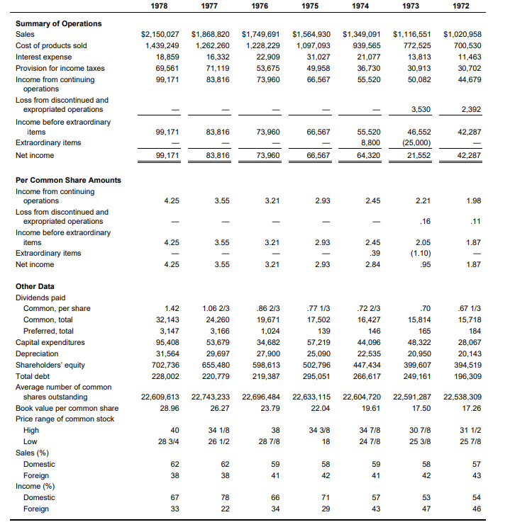

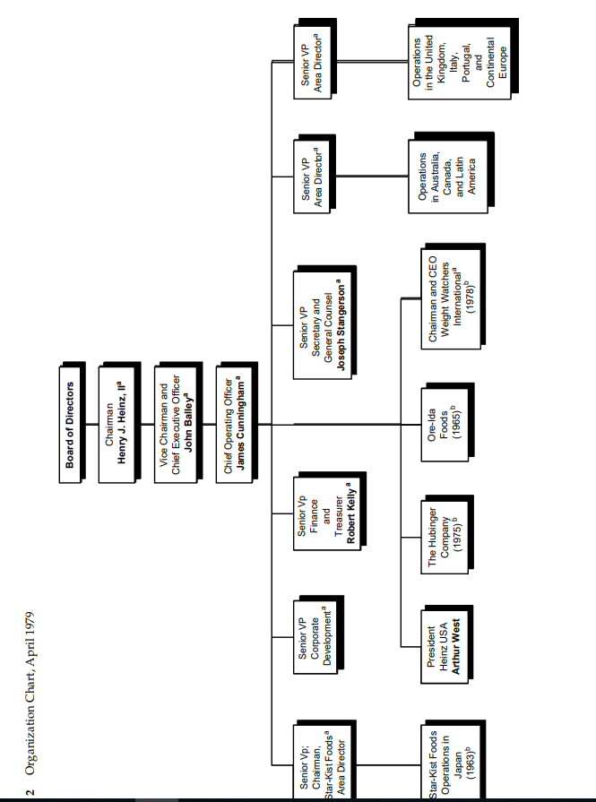
H. J. Heinz Company:
The Administration of Policy (B)
In April 1979 Heinz’s senior management learned of improper practices concerning the
transfer of an undetermined amount of reported income from one fiscal year to the next. At two of the
Heinz operating divisions payments had been made to vendors in one fiscal year, then repaid or
exchanged for services in the succeeding fiscal year. The scope of the practice and the amounts
involved were not then known.
Aware that the practice might have affected the company’s reported income over the past
seven fiscal years, management consulted an outside legal firm for an opinion on the seriousness of
the problem. Based on that opinion, John Bailey, Heinz’s chief executive officer, notified the Audit
Committee of the board of directors. Composed entirely of outside directors, this committee was
responsible for working with internal auditors and financial officers and with the firm’s outside
auditors, thus preserving the integrity of financial information published by Heinz.
The Audit Committee held a special meeting on April 26, 1979. After hearing from outside
counsel and from Joseph Stangerson (Heinz’s general counsel) about the practices, the committee
adopted a resolution retaining an outside law firm and independent public accountants to assist in a
full investigation of the matter.1
An attorney from Cravath, Swaine & Moore, the outside law firm, accompanied Stangerson
to Washington to advise the Securities and Exchange Commission of the information available and of
the investigation then under way. (An excerpt from form 8-K filed with the SEC is attached as Exhibit
1.) The two also informed the IRS of possible tax consequences of the practice
On April 27, 1979, Heinz publicly announced its investigation. “At this stage,” the formal
statement said, “it isn’t possible to determine the scope of the practice or the total amounts involved.”
It also stated that there “isn’t any reason to believe there will be any material effect on the company’s
reported earnings for any fiscal year including the current fiscal year.” While the investigation would
cover the period from 1972 to 1979, Heinz would not identify the divisions or vendors involved.
Stangerson stated: “We aren’t prepared to say whether [the practices] were legal or illegal.” He added
that the company had informed the SEC and the IRS.2
The Investigation
The Audit Committee supervised the conduct of the investigation. Teams composed of
lawyers and accountants from the two outside firms interviewed present and former company and
vendor personnel about possible improprieties. The investigators focused on the following areas:
1. practices that affected the accuracy of company accounts or the security of
company assets;
2. practices in violation of the company’s Code of Ethics;
3. illegal political contributions;
4. illegal, improper, or otherwise questionable payments; and
5. factors contributing to the existence, continuance, or nondisclosure of any of the
above.
The investigating teams interviewed over 325 Heinz employees, many of them more than once. The
teams also interviewed personnel employed by many of Heinz’s vendors, including advertising
agencies. Accounting records, correspondence, and other files were examined. The board of directors
at its regular May meeting asked for the cooperation of all officers and employees.3
On May 10, 1979, Heinz announced that a settlement had been reached in its private antitrust
suit against the Campbell Soup Company. The settlement resulted in the dismissal of Heinz’s action
against Campbell, which had been brought in 1976, and of Campbell’s counterclaim against Heinz.
The court ordered the record of the suit sealed and kept secret.4
On June 29, 1979, Heinz disclosed a preliminary figure of $5.5 million of after-tax income
associated with the income transferal practices. Stressing that this was a “very soft number,” the
company indicated that it was delaying release of audited results for FY 1979 (ended May 2, 1979)
and that its annual meeting, scheduled for September 12, would be postponed until the investigation
(which could continue well into the fall) was completed. The preliminary unaudited figures released
by Heinz showed net income of $113.4 million ($4.95 per share) on sales of $2.4 billion, after the $5.5
million deduction. Press reports indicated the investigation was being broadened to include Heinz’s
foreign units.5
On September 13, 1979, it was reported that the preliminary figure had grown to $8.5 million.
Heinz’s statement, filed with its first quarter FY 1980 earnings report, also stated FY 1979 income as
$110.4 million or $4.80 per share. Most of the $3 million growth was attributed to the discovery of
improper treatment of sales in addition to the improper treatment of prepaid expenses discovered
earlier.6
Heinz’s 1979 annual report contained audited financial statements for FY 1979 and restated
financial statements for FY 1978. The report contained an unqualified opinion from Peat, Marwick,
Mitchell & Company, Heinz’s auditors, dated November 14, 1979. In Note 2 to the 1979 financial
statements, the report also contained a restatement and reconciliation of sales, net income, and
earnings per share for the previous eight fiscal years. (The 1979 results are shown in Exhibit 2. The
restatement of FY 1971—FY 1978 are shown in Exhibit 3.) This information was filed with the
Securities and Exchange Commission on November 20, 1979.7
In February 1980 Heinz reorganized its top management structure (see Exhibit 4). Arthur
West, formerly president of Heinz USA, was promoted to world headquarters as area director. He
assumed responsibility for the Hubinger Company and Weight Watchers International, both of which
had previously reported directly to James Cunningham, Heinz’s president and new CEO. West was
also to be responsible for Heinz’s Canadian subsidiary. Heinz USA would now report through Kevin
Voight, senior vice president, rather than directly to Cunningham. Unlike other area directors, West
would be neither a senior vice president nor a member of the board of directors.8
In April 1980 Doyle Dane Bernbach, the only publicly held firm among the advertising and
consulting firms included in the Audit Committee’s investigation, admitted in an SEC filing that it
had participated in the income-juggling practices by prebilling and issuing bills that did not
accurately describe the services provided.9
On May 7, 1980, the Audit Committee presented its report to the Heinz board of directors.
The 80-page report was filed on form 8-K with the SEC on May 9, 1980. (The remainder of this case is
derived substantially from the Audit Committee’s report.)
The Findings
The Audit Committee reported widespread use of improper billing, accounting, and
reporting procedures at Heinz’s divisions including Heinz USA, Ore-Ida, and Star-Kist, and a number
of Heinz’s foreign operations. The two major areas of impropriety were:
1. Improper recognition of expenses: These were most often advertising and market
research expenses, improperly recorded in the current fiscal period when in fact
the services were performed or goods delivered in a later fiscal period. This
treatment resulted in an overstatement of expenses (and understatement of
income) in one period and a comparable understatement of expenses (and
overstatement of income) in a later fiscal period.
2. Improper recognition of sales: Sales were recorded in a fiscal period other than that
in which those sales should have been recorded under generally accepted
accounting principles.

Table A indicates the amounts involved. The accumulated effects of such practices on shareholders’
equity and working capital did not exceed 2%.
Table A Increase (Decrease) of Consolidated Income before Tax, Net of Recoveries ($ thousands)
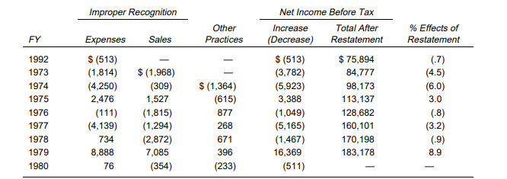

The Audit Committee indicated that these income transferal practices were designed to
adjust the income reported by divisions to corporate headquarters and were motivated primarily by a
desire to meet the constantly increasing profit objectives set by world headquarters. While division
management supported the publicly announced goal of steadily increasing profits, the committee
reported that the management incentive program (MIP) under which the goals were administered
created significant pressures. Aside from obvious personal financial considerations, many divisionlevel
personnel reportedly viewed the achievement of MIP goals as the key to advancement at Heinz.
One manager told the committee that failure to achieve these goals constituted a “mortal sin.”
The Heinz principle of decentralized authority extended to financial reporting and internal
control procedures. Division financial officers were not responsible to corporate headquarters but to
their division president or managing director. The MIP goal pressures provided the incentive, and
autonomous control the opportunity, for adopting the improper practices being reported.
One reason for using such reporting techniques was explained to the committee:
If this fiscal year’s goal is, say, $20 million net profit after tax (NPAT), it can
be anticipated that next year’s goal will be, say, 15% higher, or $23 million NPAT.
This year seems to be a good one and it is anticipated that earnings will be $24
million NPAT. But, if that figure is reported to world headquarters, it is likely that
next year’s goal will be about 15% higher than the $24 million NPAT, or
approximately $27 million NPAT. Of course, there is no assurance that there will not
be some unforeseen disaster next year. Thus, if it is possible to mislead world
headquarters as to the true state of the earnings of the [division] and report only the
$20 million NPAT, which is the current fiscal year’s goal, and have the additional $4
million NPAT carried forward into next year, the [division] will have a good start
toward achieving its expected $23 million NPAT goal next year and will not have to
reach $27 million NPAT.
Explanations for accepting these practices at lower levels included job security and the desire to
impress superiors.
The committee’s report stated: “There is no evidence that any employee of the company
sought or obtained any direct personal gain in connection with any of the transactions or practices
described in this report. Nor did the investigation find any evidence that any officer or personnel at
world headquarters participated in any of the income transferal practices described in this report.”
The report went on to describe activities at each division in greater detail.
Division Income Transfer Practices
Heinz USA. Income transfer at Heinz USA started late in FY 1974 when world headquarters
realized that Heinz USA might report profits in excess of those allowed by the wage and price
controls in effect at the time. World headquarters sought to have Heinz USA report lower profits,
although no evidence indicates that any world headquarters personnel intended GAAP to be
violated. After some commodity transactions lowered expected profits, there was a reluctance in
Heinz USA to reduce its expected profits further. Nevertheless, to accomplish the further reduction,
$2 million in invoices for services that would not be performed were obtained from an advertising
agency and recorded as an expense in FY 1974.
Heinz USA reported FY 1974 NPAT of $4,614,000. NPAT goals for the year were $4.9 million
(fair) and $5.5 million (outstanding). In calculating NPAT for MIP purposes, world headquarters
allowed an adjustment of $2 million ($1 million after tax) for advertising. This adjustment resulted in
Heinz USA achieving its outstanding goal for FY 1974. The division also received a bonus point. The
use of improper invoices to manage reported income continued after FY 1974 at Heinz USA, although
there was no evidence that world headquarters personnel knew about these transactions.
Beginning in FY 1977, additional income transfer methods were developed. Distribution
centers were instructed to stop shipments for the last few days of the fiscal year to allow the recording
of sales in the subsequent year. These instructions presented practical difficulties and some of the
shipments were not held up. Without the authorization of division senior management, paperwork
was apparently altered or misdated to record the sales as desired.
Vendors’ credits were often deferred and processed in the subsequent fiscal year to assist the
income management program. Detailed schedules were privately maintained that served as the basis
for discussions on income management. One employee had the job of maintaining private records to
insure the recovery (in subsequent fiscal years) of amounts paid to vendors on improper invoices.
The use of improper invoices spread to the departmental level as well. Individual department
managers used either prepaid billing or delayed billing, as required, to insure complete use of their
departmental budget without overspending. This practice provided protection against future budget
cuts during those periods when the full budget would not otherwise have been spent. Division
management actively discouraged these transactions.
Vendor cooperation was not difficult to obtain. One Heinz manager described it as “the price
of doing business with us.” During the period in question, 10 vendors participated in improper
invoicing at Heinz USA, and 8 participated at the department level. Most vendors’ fiscal years did not
coincide with Heinz’s.
In FY 1975 a sugar inventory write-down was used to transfer income. Sugar inventory,
valued at an average cost of 37 cents per pound, was written down to 25 cents per pound. This
adjustment, which amounted to an increase in FY 1975 expense of $1,390,360, was justified on the
basis of an expected decline in price early in the next fiscal year. This would result in lower selling
prices in FY 1976 for some division products. The lower NPAT figure that resulted was used for
establishing FY 1976 goals, but when FY 1975 performance was evaluated, world headquarters
adjusted Heinz USA’s income up by the amount of the sugar write-down. The anticipated price decline
did not occur.
At other times, inflated accruals, inventory adjustments, commodity transactions, and at least
one customer rebate were used to report income other than that required by GAAP.
Ore-Ida. Improper invoices to transfer income were also used at Ore-Ida during that period, and
the issue of obtaining these invoices was discussed at meetings of Ore-Ida’s management board. Even
though the invoices contained descriptions of services that were generic or had no correlation to the
actual services to be rendered, members of the management board believed the practice was
appropriate because comparable services would have been purchased at some point. During two
fiscal years Ore-Ida received interest payments from an advertising agency in connection with the
payment of these invoices.
Ore-Ida’s management believed that members of world headquarters’ management were
aware of the income transfer practices, but raised no objections to them. Documents submitted to
world headquarters by Ore-Ida contained references to special media billing, prebills, year-end media
billing, special billing adjustments, and advertising and promotion prebilling. Some documents
indicated that these items actually applied to the fiscal year following that of expense recognition. The
amount of these expenses was indicated each year to world headquarters’ management (in one year,
the amount was understated). In FY 1974 corporate management increased Ore-Ida’s income before
tax by the amount of the prebilled advertising expense for MIP award purposes. Ore-Ida’s
management did not know if world headquarters’ management appreciated the fact that this practice
did not conform to GAAP.
Star-Kist. Both improper expense recognition and improper sales recognition were used to adjust
reported income at Star-Kist. Improper invoices were solicited from vendors to accumulate an
advertising savings account. Sales during the last month of a fiscal year were recorded during the first
month of the next fiscal year by preventing selected documents from entering the sales accounting
system. These practices were apparently present only in Star-Kist’s marketing department.
Similar practices were also discovered at some of Heinz’s foreign subsidiaries.
Other Improper Practices
Although it focused primarily on income transferal practices, the investigation uncovered a
number of other practices. Again, the committee stated that no member of world headquarters’
management appeared to have any knowledge of these practices, and no employee sought or
obtained any personal financial gain. All of these transactions took place outside the United States.
None of the countries in which the transactions took place were identified by the committee.
In one country six questionable payments totaling $80,000 were made during FY 1978 and FY
1979. Two were made to lower-level government employees in connection with alleged violations of
import regulations. One was made to a lower-level government employee in connection with settlement
of a labor dispute. Municipal employees received one payment in connection with real estate assessments.
Labor union officials received the remaining two payments. In January 1979 three of these payments were
reported by division management to world headquarters. A brief investigation ensued and the board of
directors reprimanded certain officers of the division.
Star-Kist was involved in several transactions listed in the following section of the report:
1. In one country the payment of interest to nonresidents was prohibited. Star-Kist
collected interest on its loans to fishing fleets through the falsification of invoices
indicating the purchase by Star-Kist of supplies for the fleets.
2. In another country Star-Kist acted as a conduit through which funds flowed to
facilitate a fish purchase involving two other companies. Letters of credit
requiring the approval of the exchange authorities were used.
3. In a third country Star-Kist received checks from a fish supplier and endorsed
those checks to a wholly owned U.S. subsidiary of the supplier. These
transactions were not recorded in Star-Kist’s accounts.
The Heinz operating company in yet another country made payments for goods to individual
or designated bank accounts rather than to the supplier involved. These payments were not made
through the normal cash disbursement procedure; rather, the division was acting at the supplier’s
request.
Contributing Factors
The Audit Committee reported that only a small part of the failure to detect these practices
could be attributed to weakness in Heinz’s internal controls. In most cases, those controls were
circumvented by or with the concurrence of division management. With the autonomy enjoyed by
division management, it would have been difficult for world headquarters personnel to detect these
practices.
The committee attributed part of the problem to a lack of control consciousness throughout
the corporation. Control consciousness referred to the atmosphere in which accounting controls existed
and it reflected senior management attitudes about the importance of such controls. Clearly, control
consciousness was not then present in most Heinz divisions. The committee blamed world
headquarters’ senior management for creating an environment that was seen as endorsing poor
control consciousness:
If world headquarters’ senior management had established a satisfactory
control consciousness, internal accounting controls that were cost/benefit justified
should have been able to survive reasonable pressures to meet or exceed the defined
economic goals. In establishing this atmosphere, world headquarters’ senior
management apparently did not consider the effect on individuals in the [divisions]
of the pressures to which they were subjected.
Other factors cited by the committee included:
• corporate internal auditing personnel report to their respective division
managers and not to the director-corporate audit;
• the lack of an effective Code of Ethics compliance procedure;
• the lack of standardized accounting and reporting procedures for all Heinz
divisions;
• the lack of an effective budget review and monitoring process;
• the lack of enough competent financial personnel at world headquarters and at
the divisions; and
• the lack of a world headquarters electronic data processing manager responsible
for the control procedures of the divisions’ EDP departments.
Conclusions of the Audit Committee
1. The amounts involved in the income transferal practices were not material to the
consolidated net income or shareholder’s equity of the company in the aggregate
during the investigatory period (FY 1972-Y 1978).
2. The income transferal practices were achieved primarily through circumvention of
existing internal controls by division personnel who should have exercised
responsibility in the enforcement of such controls. Such practices were also assisted
by certain inadequacies in the internal control systems of the divisions.
3. Although world headquarters’ personnel did not authorize or participate in the
income transferal practices, their continuance was facilitated by the company’s
philosophy of decentralized management and the role played by world
headquarters’ financial personnel in reviewing the financial reports from divisions.
4. No individual employee obtained any direct financial benefit from the practices
uncovered in the investigation.
5. Perceived or de facto pressures for achievement of MIP goals contributed to the
divisions’ desirability of providing a cushion against future business
uncertainties.
6. The income transferal practices did not serve any valid corporate need.
7. The income transferal practices and other questionable practices described in this
report [of the Audit Committee] indicate the lack of sufficient control
consciousness within the corporate structure; that is, an understanding
throughout the company and the divisions that responsible and ethical practices
are required in connection with all transactions.
8. The entrepreneurial spirit of the divisions fostered by the philosophy of
decentralized autonomy should be continued for the good of the company and its
shareholders.
9. World headquarters did not have the number of competent financial personnel
needed to fulfill its role.
10. The continuance of the income transferal practices was aided by the
independence of division financial personnel from world headquarters.
11. The continuance of the income transferal practices was aided by the reporting
relationships of the internal audit staffs within the company.
12. The administration of the MIP and the goal-setting process thereunder did not
result in adequate dialogue between senior world headquarters management and
managements of the divisions.
13. The board of directors and management of the company have the duty to take all
steps practicable to ensure safeguarding the assets of the company and that all
transactions are properly recorded on the books, records and accounts of the
company.
Exhibit 1 Form 8-K Excerpt, April 27, 1979
Item 5: Other Materially Important Events
On April 27, 1979, the registrant announced that it had become aware that since 1972 in
certain of its divisions or subsidiaries payments have been made to certain of its vendors in a
particular fiscal year, which were repaid or exchanged for services by such vendors in the succeeding
fiscal year.
The registrant stated that at this stage it was not possible to determine the scope of the
practice or the total amounts involved, but that there was no reason to believe there would be any
material effect on the registrants’s reported earnings for any fiscal year including the fiscal year
ending May 2, 1979.
The Audit Committee of the registrant’s board of directors has retained the law firm of
Cravath, Swaine & Moore, independent outside counsel, to conduct a full inquiry of the practice.
Cravath, Swaine & Moore will retain independent public accountants to assist in the investigation.
The registrant has heretofore advised the Securities and Exchange Commission and the
Internal Revenue Service of the foregoing. At this time the registrant is unable to estimate the extent
of any adjustments which may be necessary for tax purposes.

